Decision type: | Single Member Decision
Decision date: | 9th September 2025
Decision maker: | Councillor Linda Smith, Cabinet Member for Housing and Communities
Decision title: | Decision to enter into a contract with Buckingham Futures for delivery Selective Licensing property inspections

Summary
Decision being taken: | For the Council, in consultation with the Group Finance Director (Section 151 Officer) and the Director of Law, Governance and Strategy (Monitoring Officer) to enter into a contract with Buckingham Futures, for an initial term of 1 year, with the option to extend up to a total of three years, at a total fixed cost of £790,500, as part the Selective Licensing scheme.
Key decision: | Expenditure, income, or savings of £750,000 or greater in the context of the medium term financial strategy,  Forward Plan Entry
Source of delegation: | Council’s Constitution Part 4.6 Delegation to Single Cabinet Member  The Leader may delegate executive responsibilities to a single Cabinet Member with or without consultation with officers or other Cabinet Members.  Cabinet Members do not have to use the delegated powers: they can ask the Leader to decide. The delegation can also be withdrawn by the Leader.  Any decisions delegated to a single Cabinet Member shall only be taken having regard to a written report submitted to them by the relevant officer within the senior management structure including any advice from the Group Finance Director and the Director of Law, Governance and Strategy.  If a Cabinet Member with delegated powers has a disclosable pecuniary interest in a matter for decision the Cabinet Member must declare the interest as required by the Members’ Code of Conduct and not exercise the delegated function. The delegated function will instead be exercised by the Leader or another Cabinet Member authorised by the Leader.  Key decision procedures and call in procedures will apply to any key decisions delegated to a single Cabinet Member.
Cabinet Member: | Councillor Linda Smith, Cabinet Member for Housing and Communities
Corporate Priority: | Good, Affordable Homes
Policy Framework: | Housing and Homeless Strategy 2023-28

The Councillor Linda Smith, Cabinet Member for Housing and Communities decides as follows:
1. | Approval to enter into a contract with Buckingham Futures for the delivery of selective licensing property inspections. The contract is for 1 year with the option to extend up to three years in total with a fixed total sum of £790,500.

Appendix No. | Appendix Title | Exempt from Publication
None | N/A | N/A

Introduction and background
- This report seeks approval to award a contract to Buckingham Futures for the delivery of selective licensing inspections for Oxford City Council. Buckingham Futures was selected through a competitive tender process, which was advertised for three weeks in August 2024 and conducted in line with procurement requirements.
- The Council’s Selective Licensing Scheme, which came into effect in September 2022, was introduced to improve the condition of private rented homes and was confirmed by the Secretary of State. The scheme has received almost 12,000 licence applications—approximately 2,000 more than originally forecast. All applications are risk-rated for inspection, and the Council aims to inspect 60% of licensed properties by the end of the scheme in August 2027.
- To help achieve this target, the Council is procuring a contractor to carry out inspections of lower-risk properties (priority two and three), allowing internal staff to focus on higher-risk cases and enforcement. The contract will enable delivery of approximately 1,300 inspections per year, with a target of around 4,000 inspections over the three-year contract term. The contractor will be paid on a per-inspection basis, rather than hourly, which ensures the Council only pays for completed work and provides clear cost control and accountability.
- The cost of this contract will be funded entirely through licence fee income. The scheme was designed to be self-financing, with the fee structure set to cover the cost of inspections. The income is held in a ring-fenced budget for the duration of the licences. Salary savings resulting from unfilled posts in 2022/23 and 2023/24 have also contributed to available funding. The total estimated cost of the contract is £790,500 over three years. Although the scheme ends in August 2027, the contract is structured as a one-year term with the option to extend for up to two additional years. This allows flexibility to adjust the contract duration in line with the scheme’s timeline and any future decision regarding its renewal, which is expected spring 2027.
- This contractor-led approach builds on successful models used previously for HMO inspections and current Food Hygiene Premises inspections. It also mitigates risks related to recruitment difficulties, as well as potential redundancy costs if the scheme is not renewed.

Reasons for the decision
- Awarding this contract will enable the Council to meet its target of inspecting 60% of licensed properties, as required by the scheme. Without the contract, there is a significant risk that the Council will fall behind on inspections, undermining the credibility and enforcement power of the scheme. A recent audit has already flagged that inspection delivery is behind schedule.
- Using a contractor model mitigates the risks associated with recruitment difficulties and ensures continuity even if the scheme is not renewed beyond 2027. It also allows the Council to retain flexibility in staffing and avoid the costs associated with redundancy should inspection needs change in the future.
- The proposed contract represents value for money, based on market comparisons and evaluation of submitted tenders. Buckingham Futures demonstrated a clear understanding of the Council’s requirements, a strong delivery plan, and a competitive price.

Alternative Options Considered
- Delivering inspections in-house: This was considered but discounted due to ongoing recruitment challenges, high training demands for graduate staff, and limited capacity to manage both inspection and enforcement work.
- Directly hiring contract workers on hourly rates: This has been used in the past but requires significant management oversight and coordination. The proposed fixed-price, per-inspection model offers clearer cost control, reduced internal management burden, and greater accountability for delivery. As such this option was discounted.
- Retendering with a revised scope or lower cost: A previous procurement was unsuccessful due to budget limitations. While the revised tender exceeds original cost projections, it reflects current market conditions, and further delays to secure a contractor will undermine the licensing regime – therefore this option has been discounted.

Equalities Impact
- Equalities impacts have been considered as part of this decision. The service being procured is a continuation of existing inspection activity under the Selective Licensing scheme, which already incorporate equalities considerations. There are no anticipated disproportionate impacts to individuals. Inspections will continue to be prioritised based on property risk rather than tenant or landlord profile.

Risks
- Failure to meet inspection targets: Risk is mitigated through contractor support and clear delivery monitoring processes.
- Cost overrun: While the contract cost exceeds original estimates, salary savings and ring-fenced scheme income offset this risk. The fixed price per inspection also limits financial exposure.
- Contractor performance: This risk is managed through the inclusion of weekly reporting, project oversight by a designated project manager, and tracking via the Council’s Metastreet system.
Carbon and Environmental Considerations
- While the inspection service involves travel within the city, the contractor has committed to minimising environmental impact through efficient route planning and, where possible, use of public transport or low-emission vehicles. The impact of the service on the Council’s overall carbon footprint is expected to be minimal. Weekly reporting will also allow the Council to monitor any issues that arise in relation to sustainability. No significant adverse environmental impacts have been identified as part of this decision.

Implications of making the decision
Financial implications | As listed above. | Completed by:  Nigel Kennedy, Group Finance Director  Date:  30/04/2025
Legal implications | As listed above. | Completed by:  Emma Jackman, Director of Law, Governance & Strategy  Date:  06/05/2025
Other implications | None. | Completed by:  David Butler, Director of Planning and Regulation  Date:  28/03/2025
Member declared interests | None. | Completed by:  Emma Jackman, Director of Law, Governance and Strategy  Date:  06/05/2025

Report author | Courtney Bennett
Job title | Regulatory Services Manager
Service area or department | Planning and Regulation
Email contact | cbennett@oxford.gov.uk

Consultee checklist
Consultees | Name and job title | Date
Senior officer | 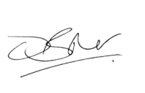  David Butler, Director of Planning and Regulation | 28/03/2025
Group Finance Director  Where required by the Constitution or conditions of the delegation | 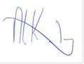  Nigel Kennedy, Group Finance Director | 30/04/25
Director of Law, Governance and Strategy  Where required by the Constitution or conditions of the delegation | 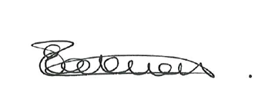  Emma Jackman, Director of Law, Governance & Strategy | 06/05/25

Decision Maker Approval
Name and job title | Date
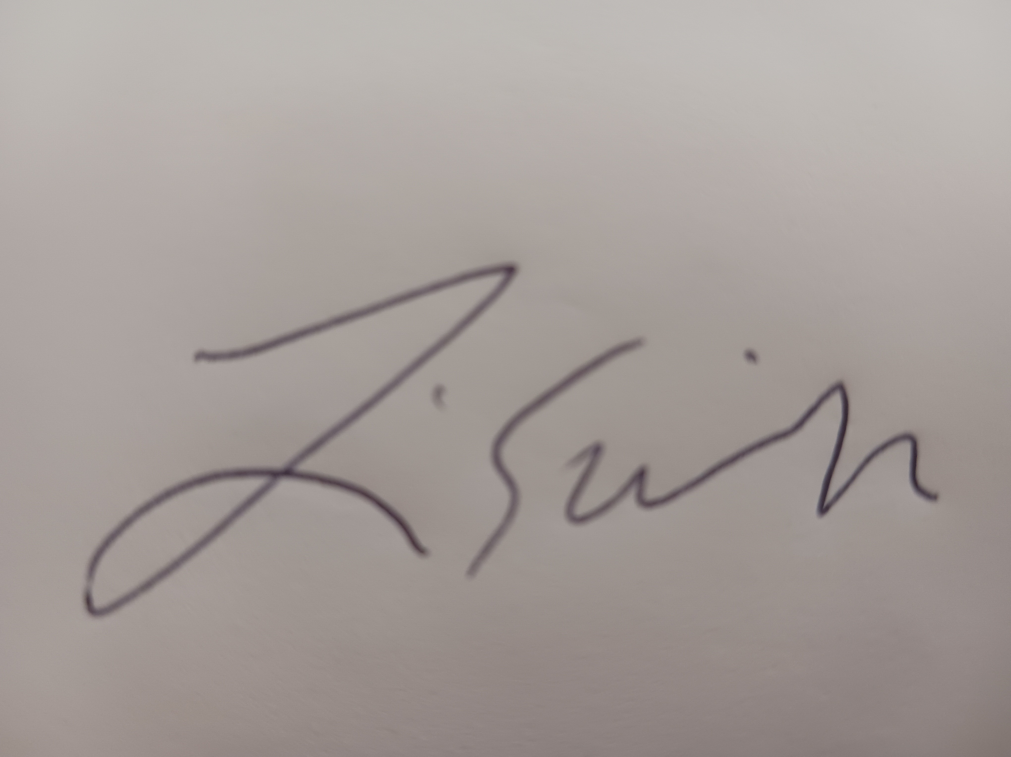  Cllr Linda Smith  Cabinet Member for Housing & Communities | 9th September 2025

